- Download the two supporting documents needed to use the dashboard: “monthly_sales.xlsx” and “SKU Attributes Report.xlsx”. Both these files have been provided.
- Upload the supporting files to the program.
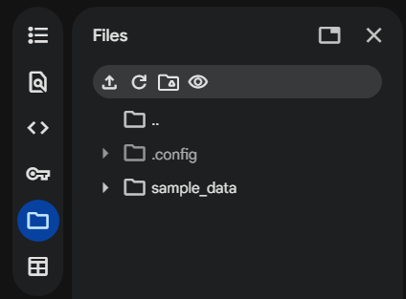
- Run all code up until the Dashboard section. Then run the code cell just under the dashboard header, creating a dashboard you can edit. Change the inputs of the dashboard but do not re-run the dashboard cell.
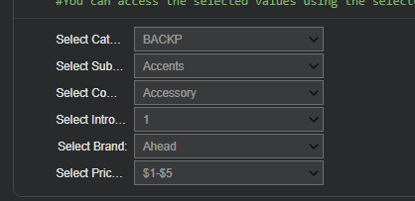
- Run the remaining code cells (do not rerun all the cells or the previous cells).
- Jump down to the monthly sales forecast section to see the high, low, and base case monthly sales forecasts as well as a visual showing the range of possible values.
